< Wireframe >

Public link: https://wireframe.cc/djuKET

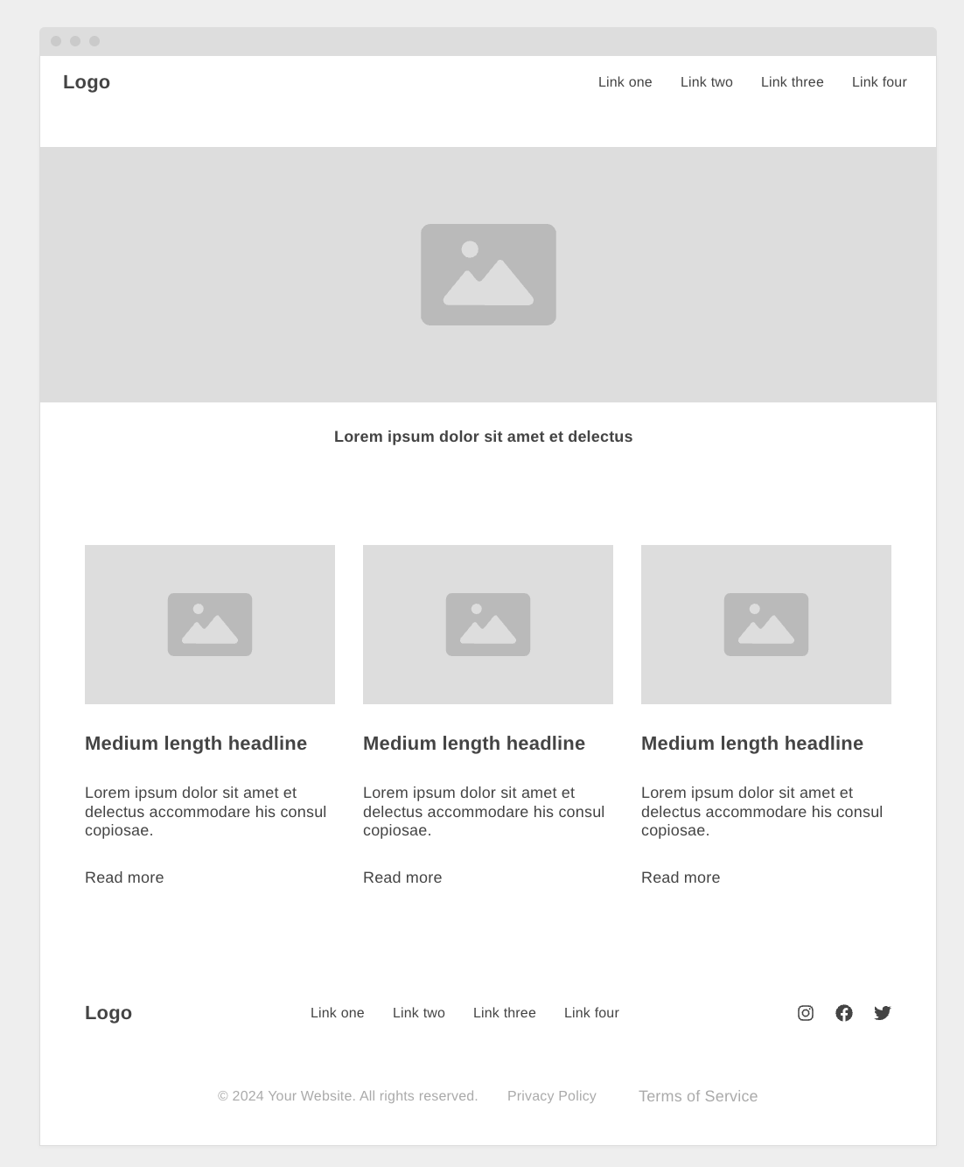

< Color >

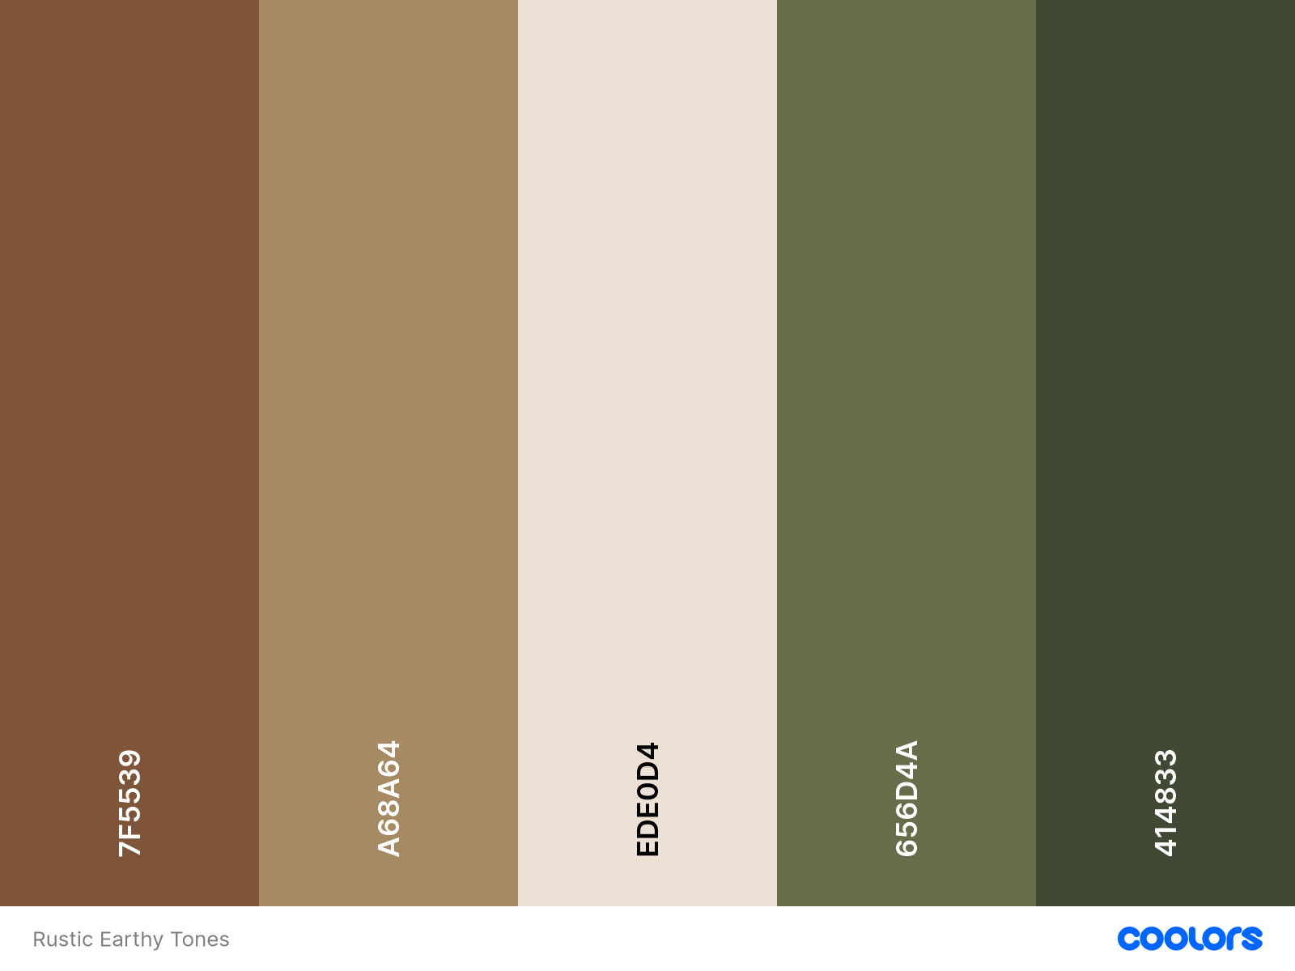

< Logo >


< Fonts >

Poppins, PT Sans, and Lato

